# 

# **SECTION A: General Project** **Overview:**

This report provides a comprehensive view of sales performance, supply chain efficiency, manufacturing performance, and product lifecycle management. It is designed to help identify growth opportunities, reduce inefficiencies, and support strategic decision-making by using Microsoft Power BI Dashboards.

## 

# **SECTION B: Supply Chain stages:**

This document provides details for a supply chain analytics project. The project includes multiple stages of the supply chain, from product information and sales, to manufacturing, inventory management, shipping, and supplier performance. The objective is to provide insights into operations efficiency, bottlenecks, and overall supply chain health.

**WE divided presented data for supply chain to Seven categories described as :**

## **Products**

It contains basic information about available products. Key Fields:

|  |  |  |
| --- | --- | --- |
| * Product type | * SKU | * prices |

## **Sales**

Sales data for each product includes customer demographic info. Key Fields:

|  |  |  |
| --- | --- | --- |
| * Product type | * SKU | * Prices |
| * Number of products sold | * Revenue generated | * Customer demographics |

## **Suppliers**

Details of suppliers and lead times. Key Fields:

|  |  |  |
| --- | --- | --- |
| * Product type | * SKU | * Order quantities |
| * Supplier name | * Location | * Lead time |

1. **Shipping**

Shipping-related data including costs and transport modes. Key Fields:

|  |  |  |
| --- | --- | --- |
| * Product type | * SKU | * Shipping times |
| * Shipping carriers | * Shipping costs | * Transportation modes |
| * Routes | | |

## **Manufacturing and Efficiency**

Production and quality control data. Key Fields:

|  |  |  |
| --- | --- | --- |
| * Product type | * SKU | * Production volumes |
| * Manufacturing lead time | * Manufacturing costs | * Inspection results |
| * Defect rates | * Costs | |

## **Inventory**

Inventory status and accepted units. Key Fields:

|  |  |  |
| --- | --- | --- |
| * Product type | * SKU | * Availability |
| * Number of products sold | * Stock levels | * Order quantities |
| * Production volumes | * Accepted units | |

## **Process Time**

* Lead times and processing durations across different stages. Key Fields:

|  |  |  |
| --- | --- | --- |
| * Product type | * SKU | * Lead times |
| * Shipping times | * Lead time | * Manufacturing lead time |
| * Production volumes | * Accepted units | |

## 

# **SECTION C: Arguments for ambiguous Data:**

* **Availability**: means available product quantities before Supply Chain Process Iin certain points
* **Revenue generated:** we recalculate the final value that equals (Number of products sold*prices)
* **Lead time:** the time taken to deliver the orders to the customers.
* **Stock levels:** ending inventory after purchasing process.
* **Lead times:** equal total product life cycle (time) (Manufacturing lead time+ Shipping times+ Lead time)
* **Order quantities:** order quantities for suppliers.
* **Production volumes:** total manufacturing quantities before defect units.
* **Manufacturing costs**: net total manufacturing costs for all accepted products manufactured.
* **Costs**: other costs related to Purchasing Proces

# **SECTION D: Calculations and Modeling Description:**

The data model shown in the image represents a well-structured relational schema designed for analyzing Supply Chain, Sales, and Manufacturing Efficiency. It integrates various business functions using a star-schema-like structure with “Products” at the core, creating relationships among several key entities. Here's a description of the components and their interrelations:

1. **Central Table: Products Table:**  
   - Primary key: SKU (Stock Keeping Unit)  
   - Acts as the bridge connecting multiple fact tables (Sales, Manufacturing, Shipping, etc.) by SKU and product type.

**Dimension Tables and Their Roles:**  
**1. Sales**  
- Connected by: SKU  
- Provides insight into financial performance and customer data for each SKU.  
  
**2. Manufacturing**  
- Connected by: SKU  
- Enables tracking of manufacturing efficiency, cost structure, and product quality.  
  
**3. Shipping**  
- Connected by: SKU and Product type  
- Contains data on distribution and logistics, linking cost directly to each product SKU.  
 **4. Inventory**  
- Connected by: Product type  
- Supports inventory management analysis and helps monitor supply-demand alignment.  
 **5. Process Time**  
- Connected by: SKU  
- Tracks time-based performance metrics, critical for operational efficiency analysis.  
  
**6. Suppliers**  
- Connected by: SKU and Product type  
- Offers insights into supplier performance and logistics.  
  
**Key Observations:**  
- SKU serves as the primary join key across most tables, ensuring a consistent reference for all product-related data.  
- Product type acts as a secondary linkage for tables like Inventory and Shipping.  
- This model supports advanced analytics, such as:  
 - Lead time breakdown by supplier and product  
 - Cost and defect rate analysis  
 - Inventory turnover  
 - Customer profitability by SKU  
- Highly efficient for use in Power BI, Tableau, or SQL-based data marts.



# **SECTION E: Dashboard results:**

# **Sales Performance Overview:**

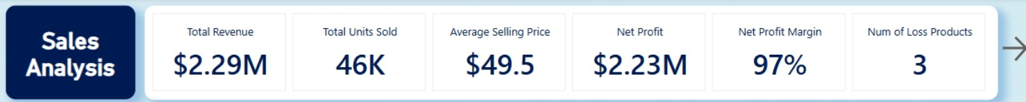

**Customer Demographics:**

* Female: 27.77%
* Non-binary: 22.95%
* Male: 16.28%
* Unknown: 33%



**Top-Performing Categories:**

* Skincare: $1.05M revenue | 21K units sold
* Haircare: $630K revenue | 14K units sold
* Cosmetics: $600K revenue | 12K units sold



Least Profitable SKUs: SKU97, SKU2, SKU5 – Minor loss impact with only 3 products underperforming

Most Profitable SKUs: SKU11, SKU47, SKU52, SKU80, SKU40 – Combined net profit: $407K



1. **Manufacturing Efficiency Overview:**

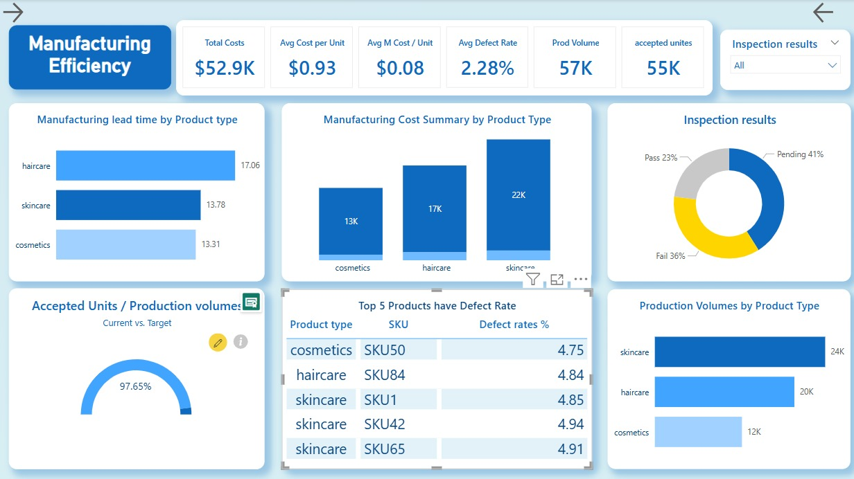

|  |  |  |
| --- | --- | --- |
| * **Total Manufacturing Costs:** $52.9K * **Average Manufacturing Cost per Unit**: $0.93   **Manufacturing Cost Summary by Product Type:**   * Skincare: $22K * Haircare: $17K * Cosmetics: $13K | **Manufacturing Lead Time by Product Type (in days):**   * Haircare: 17.06 * Skincare: 13.78 * Cosmetics: 13.31   **Production Volumes by Product Type:**   * Skincare: 24K * Haircare: 20K * Cosmetics: 12K | **Average Defect Rate by Product Type:**   * Haircare: 2.5% * Skincare: 2.3% * Cosmetics: 1.9%   **Inspection Results Breakdown:**   * Pass: 23% * Fail: 36% * Pending: 41% |

# 

# **3-Shipping and Suppliers Overview:**

|  |  |  |
| --- | --- | --- |
| * **Total Shipping Costs**: $555 * **Average Shipping Cost per Unit**: $5.55 * **Average Shipping Time**: 5.75 days * **Shipping Cost as % of COGS**: 10.5% | **Suppliers Overview:**   * Total Suppliers: 5 (All based in Bangalore) * Total Order Quantity: 5,000 units * Average Lead Time: 17 days * Lead Time Range: Min 1 day – Max 30 days | **Key Suppliers:**   * Supplier 1: 27% of total orders * Supplier 2: 22%   **Shipping Carriers Breakdown:**   * Carrier B: 42.16% of cost * Carrier C: 29.37% * Carrier A: 28.47% |



**4-Product Lifecycle Overview:**

|  |  |  |
| --- | --- | --- |
| * **Available-to-Demand Ratio**: 428% * **Average Stock Level per Product:** 47.77 units | **Inventory Turnover Rate:**   * Overall: 12.11 * Skincare: 14.92 * Haircare: 10.81 * Cosmetics: 9.51 | **Accepted Units by Category:**   * Skincare: 24,000 * Haircare: 19,000 * Cosmetics: 12,000 |



# **SECTION F: Recommendations:**

1. optimize Inventory: Address overstocked SKUs to improve cash flow and reduce storage costs.
2. Enhance Data Quality: A high percentage (33%) of unknown customer demographics suggests room for better customer data collection.
3. Improve Lead Times: Focus on streamlining shipping processes, particularly for skincare products.
4. Evaluate Supplier Performance: Review lead time efficiency across suppliers to ensure consistency and reliability.
5. Reduce Manufacturing Defects: Haircare has the highest defect rate (2.5%); review production processes to improve quality control.

